Guide for the Day of Prayer and Thanksgiving for the PCA
December 3, 2023

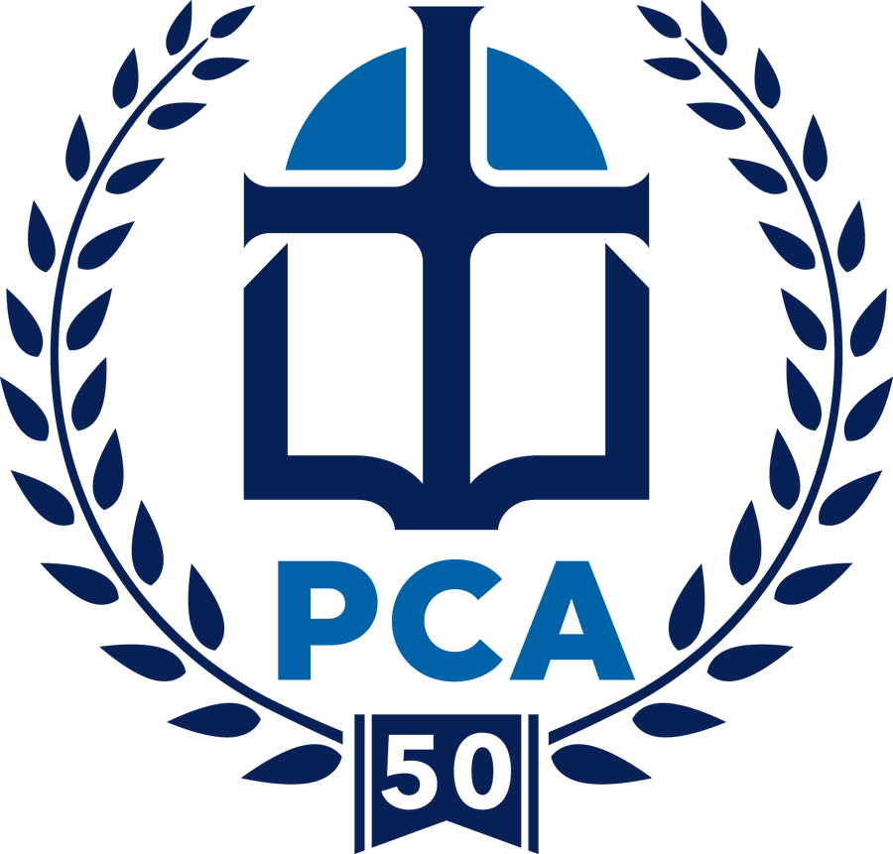

PRAISE for Christ’s enduring Church, THANKSGIVING for the foundation, rooted in God’s faithfulness, that this Convocation of Sessions laid 50 years ago for our continuing church, and PRAYER for the PCA

Please let us know you are joining in prayer. You can sign up for a time to pray, find resources, and learn more about how we are celebrating 50 years of PCA ministry at pca50.org.

December 3, 2023, is the Sunday set aside as a Day of Prayer and Thanksgiving for the PCA to celebrate the 50th Anniversary of the First General Assembly in Birmingham December 4, 1973, marking the official beginning of the Presbyterian Church in America. Our hope is that, on this day, churches across our denomination will incorporate prayer into their worship that offers:

PRAISE for Christ’s Enduring Church

- PRAISE: To our God who has promised, I will build my church, and the gates of hell shall not prevail against it. Matthew 16:18b
- PRAISE: For the Biblical Foundation of His Church. Consequently, you are no longer foreigners and strangers but fellow citizens with God’s people and also members of his household, built on the foundation of the apostles and prophets, with Christ Jesus himself as the chief cornerstone. Ephesians 2:19-20
- PRAISE that “The PCA, by Special Providence of God, the Father, was blessed with visionary Founders who called this body of believers to form a family of churches faithful to the Lord Jesus Christ” (Resolution of 2023)
- PRAISE God for 50 years of His covenant faithfulness to the Presbyterian Church in America

THANKSGIVING for the foundations, rooted in God’s faithfulness, laid 50 years ago by courageous Founders of the PCA:
- THANK Him for the prayerful commitment of churches across the nation to courageously work toward a Continuing Presbyterian Church that is:
- Faithful to the Scriptures as the Word of God,
- True to a reformed understanding of Scripture as expressed in the Westminster Confession of Faith and Catechisms
- Obedient to the Lord’s Great Commission to make known to all peoples the Good News of God’s saving grace.
- THANK Him for the 382 commissioners who gathered on December 4, 1973, at Briarwood Presbyterian Church in Birmingham, for the First General Assembly, the official start of the new denomination.
- THANK Him for the 50th General Assembly, which met in Memphis, TN in June 2023, and which was marked by unity, joy, faithfulness, and “Bright Hope for Tomorrow.”
- THANK Him for the Ministries, Committees, and Agencies of the PCA today, including:
- 570 long-term missionaries serving in 100 countries,
- 1,063 MTW Indigenous Church-planting Partners,
- 1,932 churches,
- 5,247 Teaching Elders, and
- 88 Presbyteries.

PRAYER for the PCA:
- PRAY for the Lord to continue to unite our hearts to share the vision of the PCA Founders for a Church that is “Faithful to the Bible, true to the Reformed Faith, and Obedient to the Great Commission.”
- Pray that the PCA will continue the legacy of the prayers of our Founders, uniting our hearts in praise to Him for His faithfulness, and in prayer for the denominational Committees and Agencies, the General Assembly, and the many local churches until Jesus returns.
- Pray that the PCA will continue to flourish for God’s Glory, and let us
- Keep our eyes on Jesus, the author and finisher of our faith.
- Willingly deny ourselves daily, take up our cross, and follow Christ while we wait for our blessed hope, the appearance of the glory of our Great God and Savior, Jesus Christ.

